**Project Initialization and Planning Phase**

|  |  |
| --- | --- |
| Date | 4th July 2024 |
| Team ID | 739687 |
| Project Name | WORKFORCE RETENTION SYSTEM |
| Maximum Marks | 3 Marks |

**Define Problem Statements (Customer Problem Statement Template):**

Create a problem statement to understand your customer's point of view. The Customer Problem Statement template helps you focus on what matters to create experiences people will love. A well-articulated customer problem statement allows you and your team to find the ideal solution for your customers' challenges.

|  |  |  |  |  |  |
| --- | --- | --- | --- | --- | --- |
| **Problem Statement (PS)** | **I am**  **(Customer)** | **I’m trying to** | **But** | **Because** | **Which makes me feel** |
| PS-1 | Male/female customer | Find a store closer to my residence | I don’t have a store closer to me | I travel a  lot | dissatisfied |

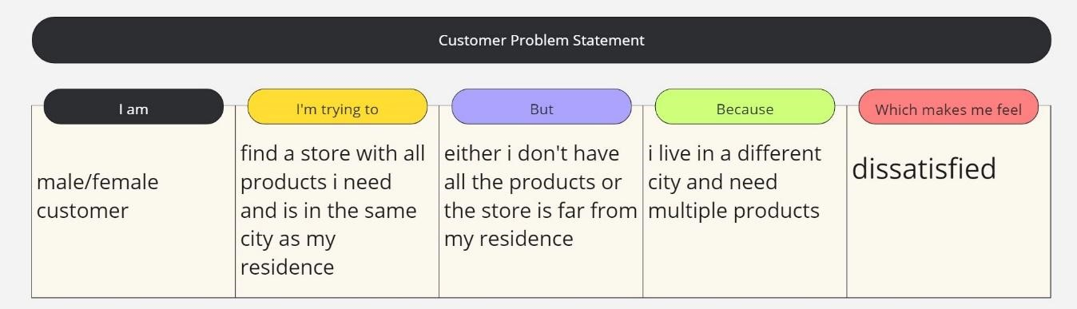Throughout the process, you’ll also be able to empathize with your customers, which helps you better understand how they perceive your product or service.

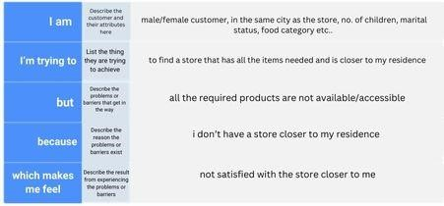

**Example:**



|  |  |  |  |  |  |
| --- | --- | --- | --- | --- | --- |
| PS-2 | Male/female customer | Find a store with food for kids | The store doesn’t have all the items needed | I have 2 children | dissatisfied |